Jesse A. Schug
September 5, 1889 – October 24, 1955

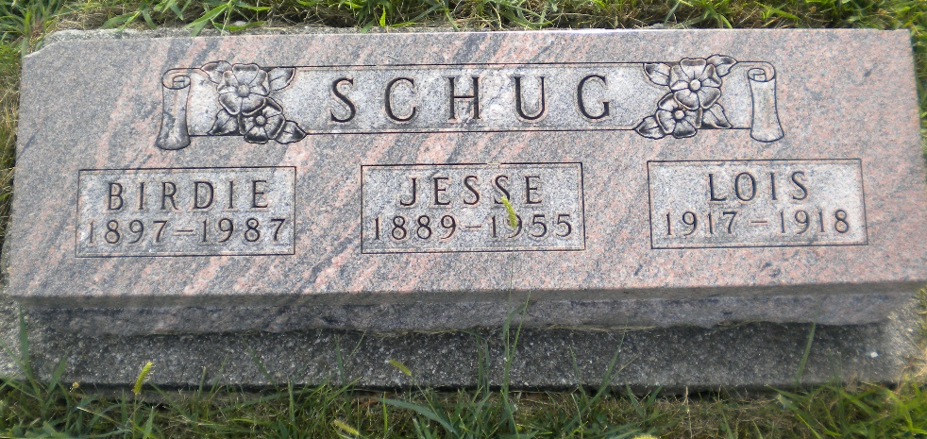
Photo by DSON1492

JESSE A. SCHUG DIES TODAY AT COUNTY HOSPITAL
Rites Here Wednesday for Former Town Marshall

Jesse A. Schug, 66 a resident (too blurry)
Mr. Schug was a member of the Cross Evangelical and Reformed church.
The body is at the Yager Funeral Home where friends may call after 11 a.m. Tuesday. Services will be held at the funeral home at 2 p.m. Wednesday, Rev. C.A. Schmid, officiating. Burial will be in the M.R.E. Cemetery.
**

Indiana, U.S., Death Certificates, 1899-2017

Name Jesse A Schug
Gender Male
Race White
Marital Status Married
Age 66
Birth Date 5 Sep 1889
Birth Place Indiana
Death Date 24 Oct 1955
Death Place Decatur, Adams, Indiana, USA
Death Registration Date 1955
Father Phillip Schug
Mother Ann Striker
Informant not named
Burial 10/27/1955 M.R.E. Cemetery

