John W. Schug
May 5, 1903 – March 7, 1976

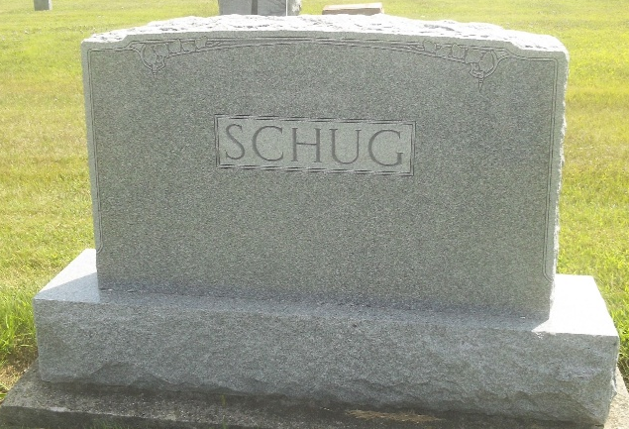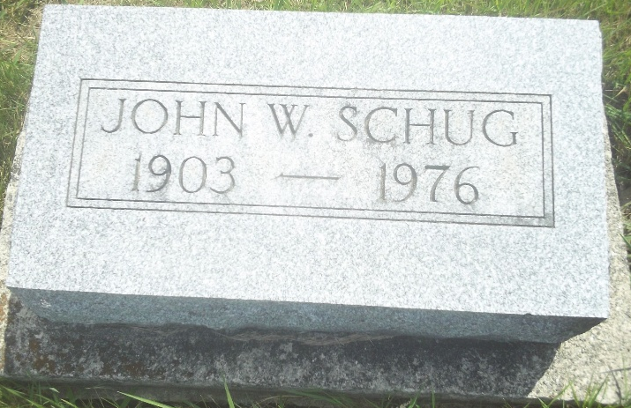
Photos by DSON1492

Indiana, U.S., Death Certificates, 1899-2017

Name John W. Schug
Gender Male
Race White
Marital Status Never Married (Single)
Military WW II
Age 73
Birth Date 5 Mar 1903
Birth Place Indiana
Death Date 7 Mar 1976
Death Place Decatur, Adams, Indiana, USA
Death Registration Date 1976
Father William Schug
Mother Clara Louise Durr
Informant Leona Schug, sister
Burial M.R.E. 3/9/1976
**

U.S., Department of Veterans Affairs BIRLS Death File, 1850-2020

Name John W Schug
Birth Date 5 Mar 1903
Death Date 5 Mar 1976
SSN xxx
Enlistment Branch Army
Enlistment Date 25 Sep 1942
Discharge Date 18 Aug 1943
Page number 4

