Henry Schug
March 11, 1883 – July 22, 1904

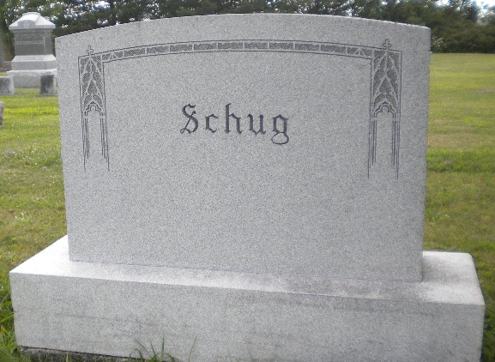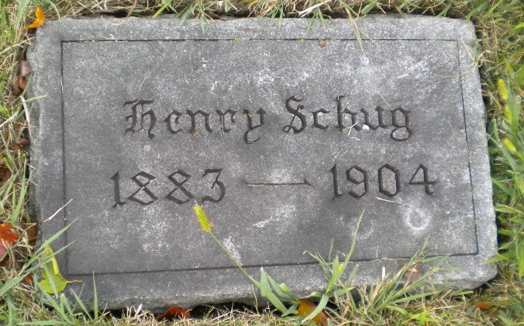
Photo by DSON1492

Indiana, U.S., Death Certificates, 1899-2017
Name Henry Schug
Gender Male
Race White
Marital Status Single
Age 21
Birth Date 11 Mar 1883
Birth Place Adams County, Indiana
Death Date 22 Jul 1904
Death Place Berne, Adams, Indiana, USA
Death Registration Date 1904
Father Chas C Schug, informant
Mother Katie Stauffer
Burial M.R.E. Cem. Jul 24, 1904
**

Henry Schug from tree Ketchum Family

Birth Mar 1883 Berne, Adams, Indiana, USA
Residence 1900 Monroe City, Adams, Indiana, USA
Death 22 Jul 1904 Berne, Adams, Indiana, USA
Father Charles C Schug (1856-1926)
Mother Catharina A. Stauffer (1854-1890)
2235 People 2 Records 3 Sources

