Emma Frances (Kelley) Schug
May 11, 1875 – March 22, 1947

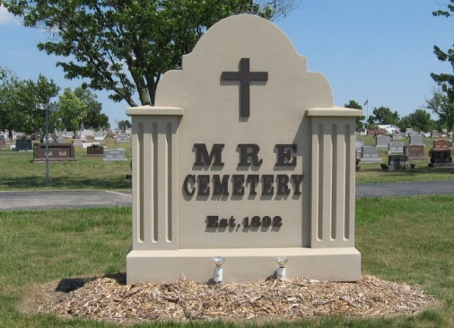
Photos by Tombstoner & Family

SCHUG FUNERAL TO BE HERE ON TUESDAY MORNING
Widow of Julius Schug Dies Here on Saturday Morning

Funeral services will be held at 10:00 Tuesday morning at the Trinity Evangelical U.B. Church here for Mrs. Emma Frances Kelly Schug, 71, widow of the late Julius C. Schug, who died here at 7:50 o'clock Saturday morning. Mrs. Schug died at the Elmer R. Liechty apartment on West Main Street. The Rev. C. P. Maas, pastor of the Evangelical U.B. Church will officiate at the funeral and burial will be in the MRE Cemetery. She was a member of the local church.
Mrs. Schug, who was widely and prominently known, had not been well for several years and had been seriously ill the past two weeks. Her condition was critical for several days before her death. The cause of death was given as complications.
Mrs. Schug was born at Chattanooga, Ohio, May 11, 1875, the daughter of Samuel and Minerva Deyo Kelley. She was married to Julius Schug and he preceded in death February 14, 1921. Mrs. Schug spent most of her life in Fort Wayne with her daughter, Mrs. Elmer R. Liechty. Her late husband operated the former Schug Hardware here many years ago.
Surviving are the following children: Velma, wife of Col. Irvin Hirschy, now residing at Frankfort, Germany, where Col. Hirschy is with the American Army of Occupation; Mrs. Elmer R. (Katherine) Liechty, Berne; Walter Schug, Berne and Mrs. R. L. (Vera) Black of Gainesville, Florida. The following brothers and sisters survive; Samuel J. Kelley, Fort Wayne; Mrs. Mary Sipe, Berne Route 2 and Charles C. Kelley, Auburn. Eight Grandchildren survive. Two of them are in Japan. They are Pvt. Jack Schug and T-Sgt R. L. Black.
One daughter preceded in death in infancy.

Adams County, Indiana Historical Museum
1947Jan-May Scrapbook, image 97
Handwritten-Mon. March 24, 1947

