Ellen Elizabeth Schug
November 21, 1912 – January 24, 1913

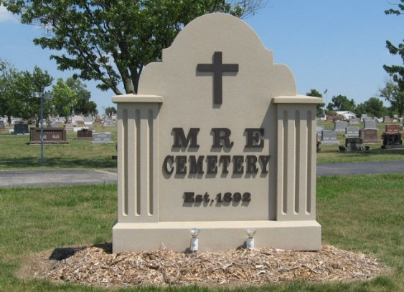
Photos by Tombstoner & Family

Indiana, U.S., Death Certificates, 1899-2017
Name Ellen Elizabeth Schug
Gender Female
Race White
Age 2/12
Birth Date 21 Nov
Birth Place Indiana
Death Date 21 Jan 1913
Death Place Berne, Adams, Indiana, USA
Death Registration Date 1913
Father G. C. Schug
Mother Emma L. Schug
**

Biery-Yager Funeral Homes Records, Berne, Indiana
November 5, 1910 – December 28, 1916

Name Ellen Elizbeth Schug
Charge to Julius Schug
Date of Death Jan 21
Date of Funeral Jan 23
Place of Death Berne
Cause of Death bronchial pneumonia
Interment MRE

