Clara Louise (Durr) Schug
December 6, 1870 – May 21, 1948

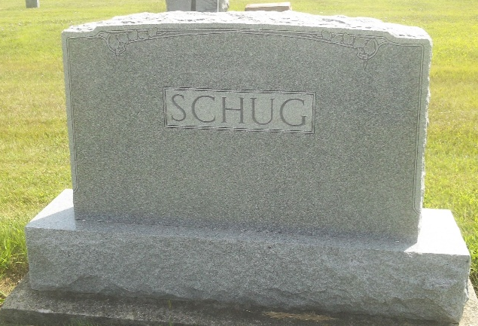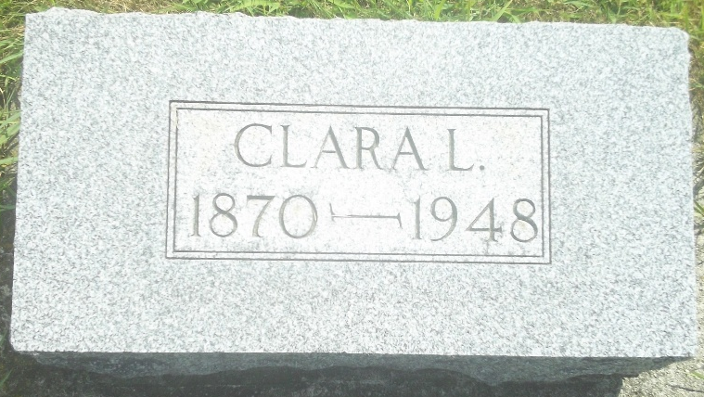
Photos by DSON1492

Indiana, U.S., Death Certificates, 1899-2017
Name Clara Schug
[Clara Durr]
Gender Female
Race White
Marital Status Widowed
Age 77y 5m 15d
Birth Date 6 Dec 1875
Birth Place Indiana
Death Date 21 May 1948
Death Place Berne, Adams, Indiana, USA
Death Registration Date 1948
Father Fredrick Durr
Mother Christina Bettekofer
Spouse Wm Schug
Informant John Schug
Burial 5-23-1948 M.R.E.

