Charles C. Schug
October 30, 1856 – January 12, 1926

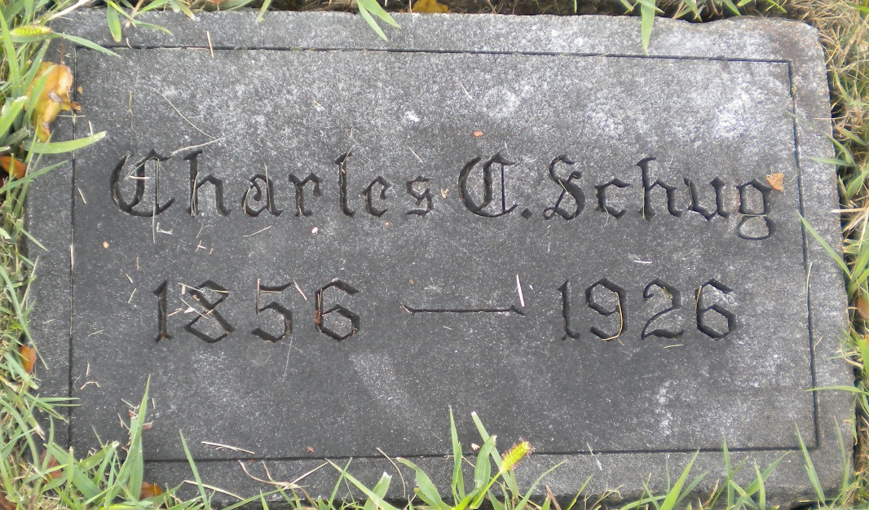
Photo by DSON1492

Indiana, U.S., Death Certificates, 1899-2017

Name Charles C Schug
Gender Male
Race White
Marital Status Widowed
Age 69y 2m 12d
Birth Date 31 Oct 1856
Birth Place Tuscarave Co O
Death Date 13 Jan 1926
Death Place Berne, Adams, Indiana, USA
Death Registration Date 1926-1927
Father Carl Schug b. Prussia Germany
Mother S Cathrine Rausch b. Prussia Germany
Informant Miss Clara Schug
Burial M.R.E. Cemetery 1/16/1926

