Catherine (Stauffer) Schug
January 15, 1854 – June 9, 1890

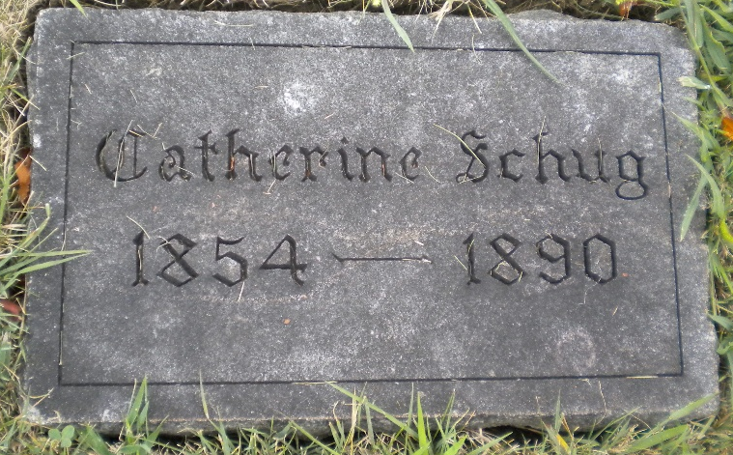
Photo by DSON1492

Indiana, U.S., Marriage Certificates, 1960-2012

Name Catharine Stauffer
Gender Female
Marriage License Date 8 Dec 1880
Marriage Date 9 Dec 1880
Marriage Place Adams, Indiana, USA
Spouse Charles Schug
**

Catharine Stauffer from tree Stauffer Tree

Birth 15 Jan 1854 Indiana, USA
Residence 1880 Adams, Indiana, USA
Death 9 Jun 1890
Father John Stauffer (1821-1887)
Mother Anna Steiner (1823-1908)
Spouse Charles C. Schug (1856-1926)
102127 People 8 Records 8 Sources

John Stauffer – Ann Steiner by Allen E. Rupp, Marietta, Ohio, March
1973
