Carl Schug
November 26, 1825 – March 3, 1869

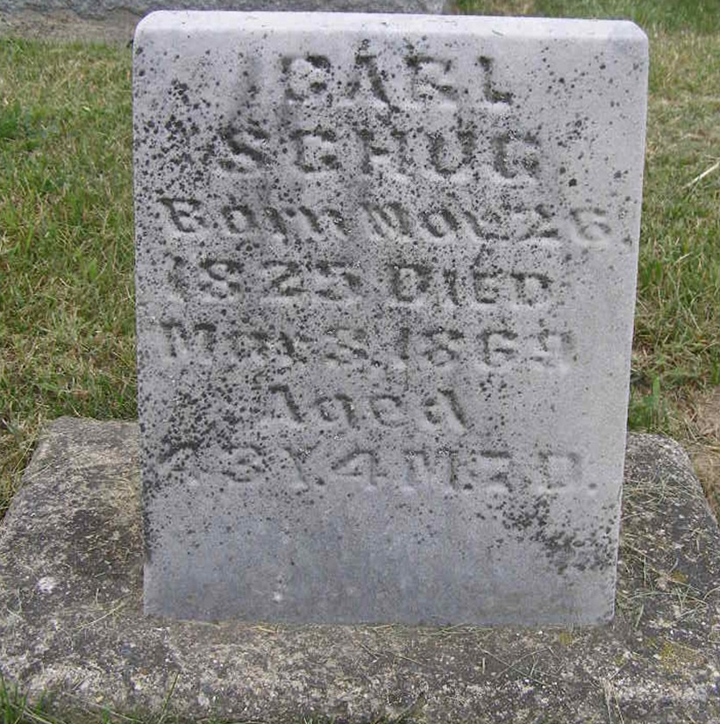
Photo by Shaunda Bedwell Opdycke

Web: RootsWeb Cemetery Index, 1800-2010

Name Carl Schug
Birth Date 1825
Death Date 1869
Burial Place Adams, Indiana, USA
Cemetery M.R.E. Cemetery
**

Carl Schug from tree Alvin Family Tree

Birth 26 Nov 1825 Baumholder, Birkenfeld, Rhineland-Palatinate, Germany
Marriage 2 May 1850 Port Washington, Tuscarawas, Ohio, USA
Death 3 Mar 1869 Vera Cruz, Wells, Indiana, USA
Father Johann Schug (1792-1827)
Mother Katharina Louisa Kirsch (1784-1880)
Spouse Cathrina Rausch (1833-1902)
4691 People 7 Records 13 Source

