Calvin Matthieas Schug
July 18, 1882 – April 24, 1928

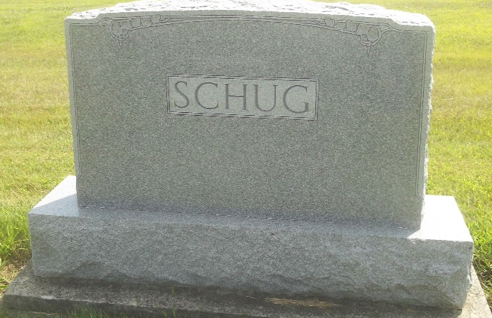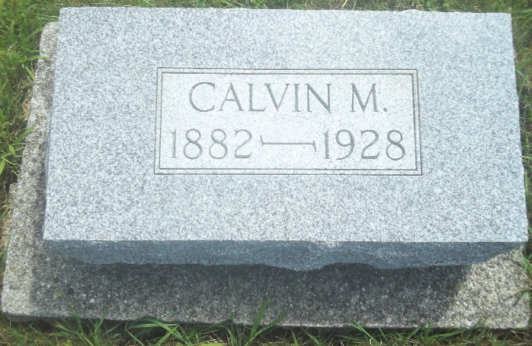
Photo by DSON1492

Indiana, U.S., Death Certificates, 1899-2017

Name Colvin M. Schug
Gender Male
Race White
Marital Status Single
Age 46
Birth Date 18 Jul 1882
Birth Place Indiana
Death Date 24 Aug 1928
Death Place Monroe, Adams, Indiana, USA
Death Registration Date 1928
Father Wm F. Schug, informant
Mother Elverta Striker
Burial M.R.E. Cem 8-27-1928

