Birdie Marie (Hoffman) Schug
April 29, 1897 – December 11, 1987

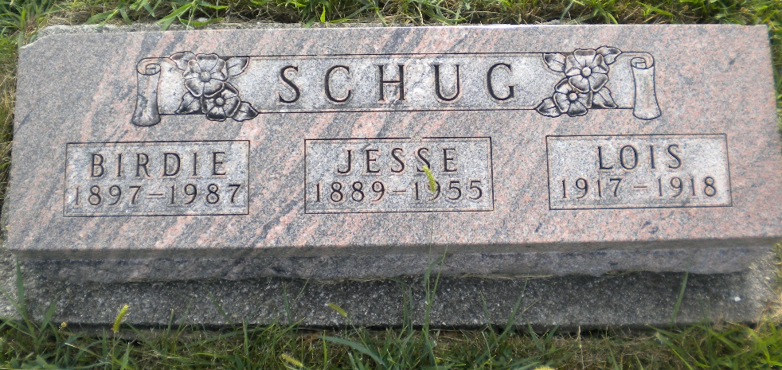
Photo by DSON1492

Birdie Schug, 90, 1104 Lewis Dr., who lived most of her life in Berne, died Friday at 4:20 p.m. in Parkview Memorial Hospital, Fort Wayne.
She attended Cross United Church of Christ, Berne, and was a former employee of Berco Co. and Parkway Restaurant in Berne, and later worked at Richards Restaurant in Decatur.
Born on April 29, 1897, in Hartford City, she was the daughter of Charles and Elizabeth Barnes-Hoffman, and was married to Jesse Schug; he died Oct. 24, 1955.
Survivors include two daughters, Mrs. Richard (Jeanne) Kelley, route 5, Decatur and Corabelle Beer, Decatur; three sons, Frederick Schug, Decatur, Robert Schug, Ocala, Fla., Philip Schug, San Antonio, Tex.; one brother, Charles Hoffman, Clearwater, Fla.; one sister, Ila Saults, Traverse City, Mich.; 16 grandchildren; 17 great-grandchildren. One son, Henry, one daughter, Lois, one brother and two sisters are deceased.
Services will be held at 2 p.m. Monday at Yager-Kirchhofer Funeral Home, Berne, where friends may call Sunday from 2-9 p.m. and Monday from 9 a.m. until 12:30 p.m. Burial will be in MRE Cemetery, Berne.

Decatur Daily Democrat, Adams County, Indiana
Satu., Dec. 12, 1987

