Bessie (Tremp) Schug
November 11, 1908 – June 29, 1988

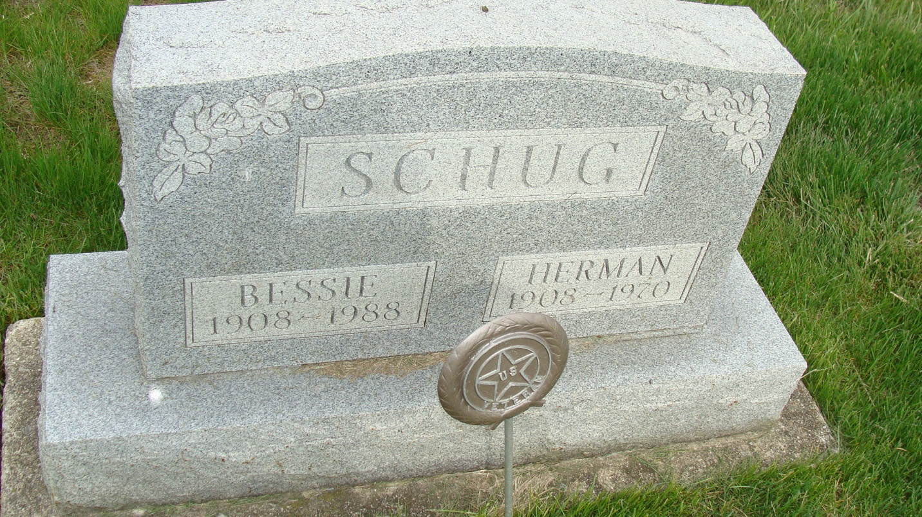
Photo by Alicia Kneuss

Indiana, U.S., Death Certificates, 1899-2017

Name Bessie Schug
[Bessie Tremn]
Gender Female
Race White
Marital Status Widowed
Age 79
Birth Date 11 Nov 1908
Birth Place Adams County, Indiana
Death Date 29 Jun 1988
Death Place Berne, Adams, Indiana, USA
Death Registration Date 1988
Father Frank Tremp
Mother Sarah Reinhard
Informant Betty Zurcher, daughter
Burial 7/1/1988 M.R.E.

