Alverga DeLee (Garlinger) Schug
August 23, 1915 - May 30, 2008

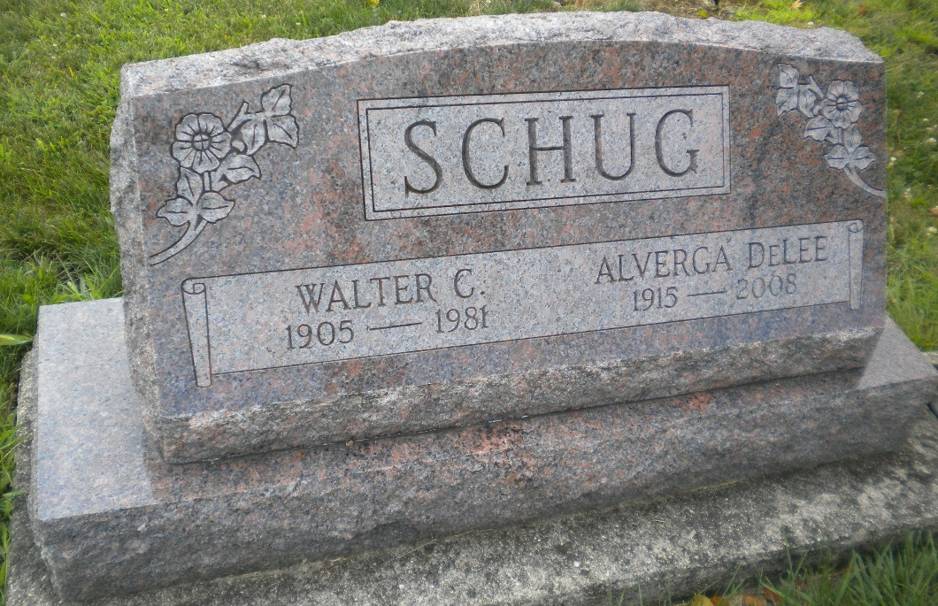
Photos by DSON1492

DeLee Schug, 92, died Friday, morning, at Swiss Village, Berne. De Lee was born on August 23, 1915 in Indiana to Harold and Dolly (Myers) Garlinger who are deceased. She married Walter "Wassie” Schug who died in 1981. DeLee was employed at Swiss Village where she retired. Her hobbies included gardening, sewing, & crocheting.
Dee is survived by step-daughter, Alice (Charles) Stevens, Ann Arbor, Mi., step-son, Jack Schug, Huntington, her sister, Carolyn Huey, Portland, brother James Garlinger, Hobrook, Arizona. Dee was preceeded in death by three brothers, Roger, Woodrow, & Kenneth, sisters, Mabel Trasch, Janice Garlinger, step-son, Paul Schug, & step daughter Shirley Sprunger, and a nephew, Michael Engle.
Funeral services are Tuesday, June 3 at 10 am at Yager-kirchhofer F. Home, Berne. Visitation at the funeral home Monday, 6 to 8pm and Tuesday one hour prior to services at the funeral home. Preferred memorials are to Swiss Village.

Yager-Kirchhofer Funeral Home, Adams County, Indiana

