Alverda J. (Striker) Schug
April 29, 1864 – February 2, 1895

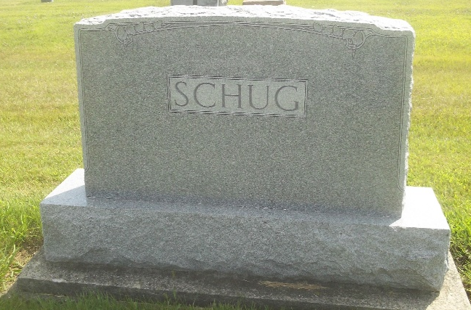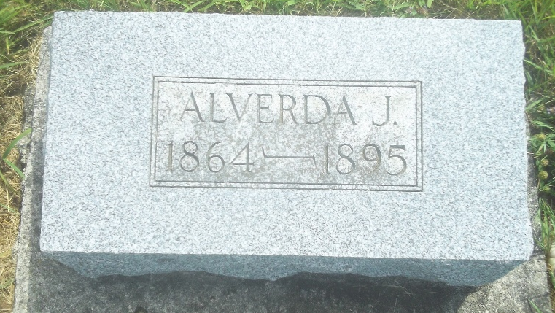
Photos by DSON1492

Berne Items

The death of Mrs. Wm. Shugg occurred on last Saturday. The remains were placed in the Berkenstove cemetery. Rev. Ruff officiated.

Democratic Press, Adams County, Indiana
Thursday, February 7, 1895
**

Trustee Schugg of Monroe Township, died and was buried in the Backtaw Cemetery Monday. He had been afflicted with consumption and was sick for some length of time, and bore his sufferings with great fortitude. He was about forty years of age and leaves a family of six children, as well as many friends.

Democratic Press, Adams County, Indiana
Thursday, February 7, 1895
**

By a misunderstanding on our part we stated last week that Trustee Schugg of Monroe Township was dead. It should have read Mrs. Schugg, the estimable wife of this trustee.

Democratic Press, Adams County, Indiana
Thursday, February 14, 1895

