Bonita Gail Schrock
April 19, 1949 – April 19, 1949

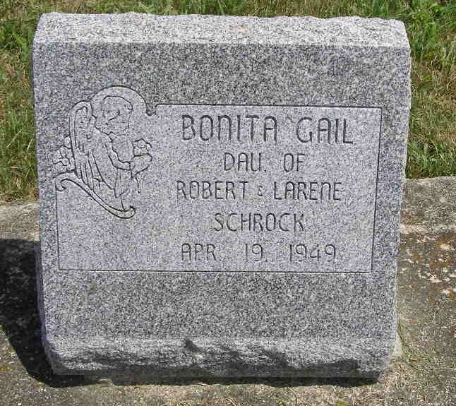
Photo by Shaunda Bedwell Opdycke

Bonita Gale Schrock from tree Landon Schrock Family Tree

Birth 19 Apr 1949 Berne, Adams, Indiana, USA
Death 19 Apr 1949 Berne, Adams, Indiana, USA
Father Robert Dale Schrock (1922-1996)
Mother Larene J. Schrock (1925-1999)
72 People 1 Record 2 Sources

