Laundon J. Scholer
September 30, 1961 - November 12, 2008

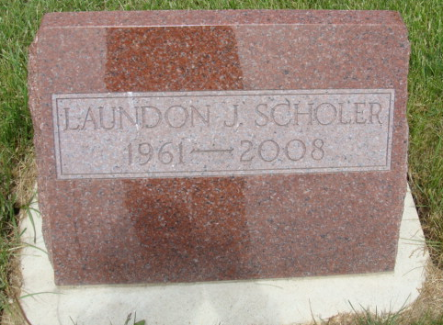
Photo by Alicia Kneuss

Laundon J. Scholer, 47, of Berne, Indiana passed away at his home on Wednesday, November 12, 2008. Laundon was born on September 30, 1961 in Adams County, Indiana the son of Glen and Judy (Yager) Scholer.
Laundon attended the Cross Community Church in Berne, Indiana. He was employed by Fleetwood Industries of Decatur, Indiana, CTS Corporation and Pine Lake, both of Berne, Indiana. He was a member of the Fort Wayne National Guard.
Laundon is survived by his parents, Glen and Judy Scholer of Berne, Indiana; a daughter, Alexa Scholer of Pennville, Indiana; his former wife, Krista Scholer of Pennville, Indiana; a brother, Dr. Seth (Caroline) Scholer of Nashville, Tennessee; a brother, Shaun (Rebecca) Scholer of Carmel, Indiana; a brother, Dr. Aaron (Colleen) Scholer of Auburn, Maine; and a sister, Christa (Jim) Boland of Apex, North Carolina.
Funeral services will be held at 2:30 p.m. Sunday, November 16, 2008 in the Cross Community Church in Berne, Indiana with the Rev. Randall Luther officiating. Interment will follow in the M.R.E. Cemetery of Berne, Indiana. Family and friends will be received from 4:00 – 8:00 p.m. Saturday, November 15, 2008 in the Yager-Kirchhofer Funeral Home in Berne, Indiana and one hour prior to the service at the church on Sunday. Preferred memorials are to the Cross Community Church of Berne, Indiana.

Yager-Kirchhofer Funeral Home, Adams County, Indiana

