Stanley F. Schneider
April 28, 1920 - May 22, 2010

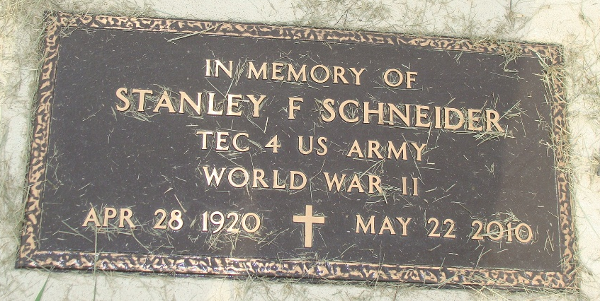
Photo by Alicia Kneuss

Stanley F. Schneider, 90, of Geneva, Indiana passed away at 9:55 p.m. Saturday, May 22, 2010 at his residence. Stanley was born on April 28, 1920 in Gilberts, Illinois the son of William and Edith (Dolby) Schneider, both deceased. He married Joan Swenson on September 29, 1945 and she survives.
Stanley was a member of the First Baptist Church of Freeport, Illinois. He was a World War U.S. Army Veteran serving in the Signal Corp. Stanley was the owner of Schneider Construction Company and was a farmer. He was the Board Chairman and member of the Chapel Crusade Mission Board of Winona Lake, Indiana.
Stanley is survived by his wife Joan Schneider of Geneva, Indiana; a daughter, Connie (Ed) Krupp of Geneva, Indiana; a daughter, Virginia (Larry) Vrieze of Puyallup, Washington; a son, Robert (Jeanne) Schneider of Carmel, Indiana; a son, Tom (Lindy) Schneider of Peoria, Arizona, and a brother, Robert Schneider of Topeka, Kansas. Other survivors include twenty grandchildren and twelve great-grandchildren.
Stanley was preceded in death by brothers; William, Edward, and Frankie Schneider and sisters; Edith Battin, Bessie Rediger, and Dorothy Johnson.
There will be a private family service with no visitation.

Yager-Kirchhofer Funeral Home, Adams County, Indiana

