Verena ‘Fannie’ (Neuenschwander) Schneck
August 31, 1860 – June 1, 1934

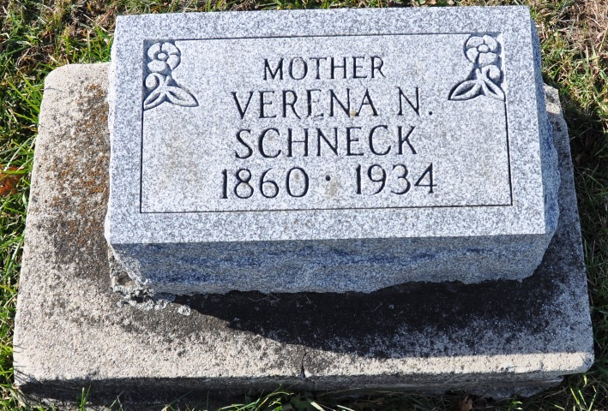
Photo by Deb Curry

Indiana, U.S., Death Certificates, 1899-2017

Name Verena Schrick
[Verena Newrickwander]
Gender Female
Race White
Marital Status Widowed
Age 73y 9m
Birth Date 31 Aug 1860
Birth Place Indiana
Death Date 1 Jun 1934
Death Place Berne, Adams, Indiana, USA
Death Registration Date 1934
Father Christian Neuenschwander b. Switzerland
Mother Anna Lehman b. Switzerland
Informant Mrs. Ralph Stager
Burial M. R. E. Cemetery 6-3-1934
**

Indiana, U.S., Marriages, 1810-2001

Name Fanny Neuenschwander
Gender Female
Race White
Event Type Marriage Registration (Marriage)
Birth Place Indiana
Marriage Date 29 Aug 1897
Marriage Place Berne, Indiana, United States
Residence Place Berne, Indiana
Father Christian
Mother Lehman
Spouse Abraham C Schneck
Page 51
FHL Film Number 002321357

