Edwin C. Schneck
December 25, 1879 – January 9, 1930

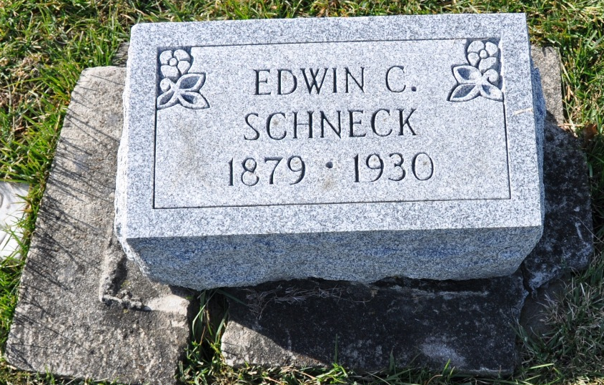
Photo by Deb Curry

BODY OF FORMER BERNE CITIZEN FOUND ELEVEN WEEKS AFTER DROWNING
Berne, Ind., March 28 - Exactly eleven weeks after Edwin Schneck, 50, well known former Berne man, fell into the Chicago river in Chicago, his body was recovered Thursday evening at 5:10 o'clock nearly on the same spot where he disappeared, according to information received here last evening by his stepmother, Mrs. Abraham Schneck, and by his halfsister, Mrs. Ralph Stager.
For more than twenty years before his death. Mr. Schneck was a member of a fire department on a fire boat, and those who found his body floating on the cold water of the Chicago river are his former fellow firemen. He was immediately recognized as the long missing member of their crew and his widow and daughter were immediately notified, who in turn at once sent word to his brother, Albert Schneck at Ft. Wayne and to relatives here.
The body will be brought to Berne Saturday afternoon for burial. It is not in condition, however, that his many friends here may view it.
It will be held at the Bierie & Yager undertaking room until funeral service, which will be held on Sunday afternoon at 1:30 o'clock at the Mennonite church, and burial will be in the M. R. E. cemetery.
It will be remembered that Mr. Schneck disappeared on Thursday afternoon, January 9, when he stepped from his fire boat, the Greham-Stewart to go to the Medill, another boat, for a cup of coffee.
Two hours later he was noticed missing, and since no one witnessed his tragedy, his disappearance it is thought that he either slipped into the river off an icy barge or else collapsed with a heart attack, to which he was subject, and fell into the river unconsciously. Just how it happened will never be known.
The search for his body has been perpetual ever since his disappearance, and, although the finding of his body will refreshen the sorrow to his family caused by his death, they are greatly relieved by the recovery of the body. Features of his body were easily recognizable and firemen immediately identified it as that of Mr. Schneck. Soon after it was removed from the water, its condition became bad so that it can not be shown.
It is thought that perhaps due to the severe storm in the midwest, the worst of which seemed to have been in the region of Chicago, and perhaps the change of temperature of the water, may have helped to bring up the body from the deep river.
The deceased was a son of the late Abraham Schneck and spent the years of his youth in Berne.
His widow and a daughter Loraine survive, besides a brother Albert in Fort Wayne, two sisters, Mrs. Fred Neilson and Mrs. Ira Lee Gregory, both of Portland, Oregon; a half brother Ivan in Chicago and a half sister, Mrs. Ralph Stager in Berne and his step-mother, Mrs. Schneck here. - Berne Witness.
Mennonite Weekly Review, Newton, Kansas
02 Apr 1930, Wed • Page 1
**
Death • Illinois, Cook County Deaths, 1871-1998
Name Edwin C Schneck
Sex Male
Age 50
Address 2027 Grace
Burial Date 29 Mar 1930
Burial Place Berne, , Indiana
Birth Date 25 Dec 1879
Birthplace Exton, , Missouri
Marital Status Married
Occupation Engineer
Race White
Father's Name Abraham Schneck
Mother's Name Reva Sischel
Spouse's Name Augusta Schneck
Informant's Name Lorraine C Schneck
Event Type Death
Event Date 09 Jan 1930
Event Place Chicago, Cook, Illinois, United States
Entry Number 9160
Cemetery M R E
Funeral Home Westem And Co

