Abraham Schneck
February 11, 1846 – October 23, 1914

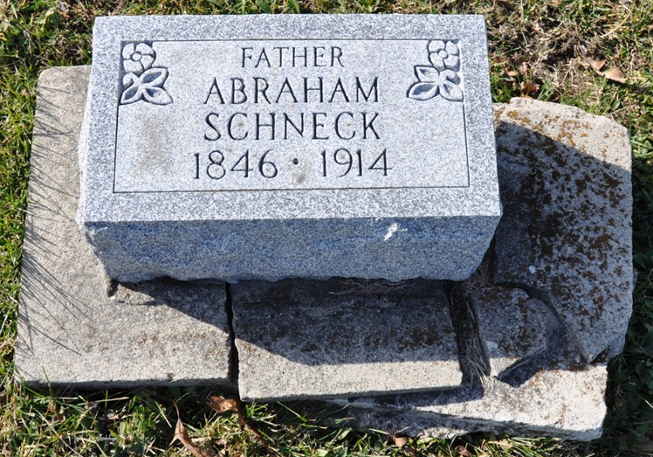
Photo by Deb Curry

Indiana, U.S., Death Certificates, 1899-2017

Name Abraham Schneck
Gender Male
Race White
Marital Status Married
Age 68y 8m 12d
Birth Date 11 Feb 1846
Birth Place Switzerland
Death Date 23 Oct 1914
Death Place Berne, Adams, Indiana, USA
Death Registration Date 1910-1919
Father Christian Schneck b. Switzerland
Mother Elizabeth Lehman b. Switzerland
Spouse Varina Schneck
Informant Albert Schneck
Burial M.R.& E. 10-25-1914
**

Biery-Yager Funeral Home Record, Adams County, Indiana
Abraham Schneck; Died October 23, 1914 at Berne from dropsy; Age 68 years, 8 months; Occupation Night Watch; Funeral October 25, 1914; Burial MRE Cemetery; Lot or Grave # 256

