Eugene Vernon Schlotzhauer
January 24, 1918 – Marcy 17, 1919

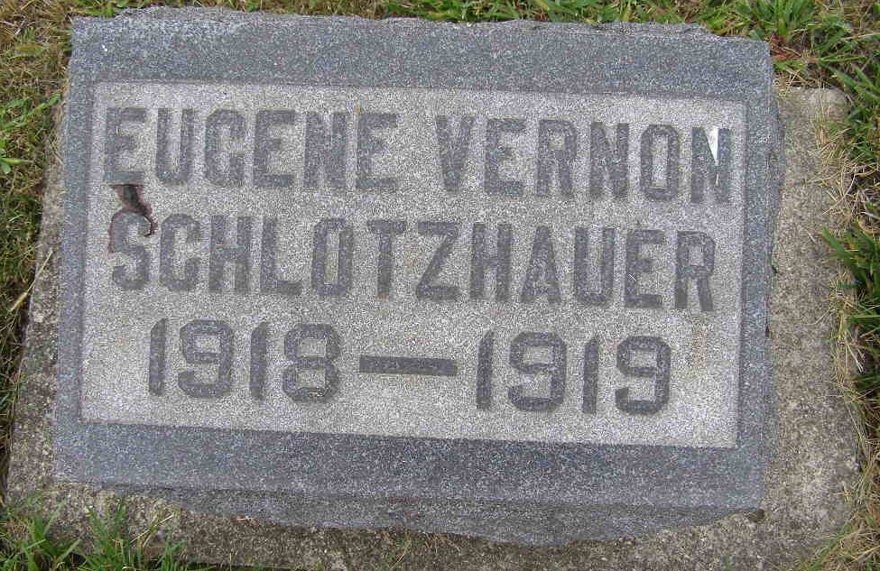
Photo by Shaunda Bedwell Opdycke

Indiana, U.S., Death Certificates, 1899-2017

Name Eugine Vernon Schlotzhaner
Gender Female
Race White
Age 1y 3m 23d
Birth Date 24 Jan 1918
Birth Place Indiana
Death Date 17 Mar 1919
Death Place Beme, Adams, Indiana, USA
Death Registration Date 1919
Father Noah Schlotzhaner b. Canada, informant
Mother Amanda Neuhauser
Burial M.R.E. Cem. 3/20/1919

