Luetta (Liddy) Schlagenhauf
December 28, 1880 – December 23, 1952

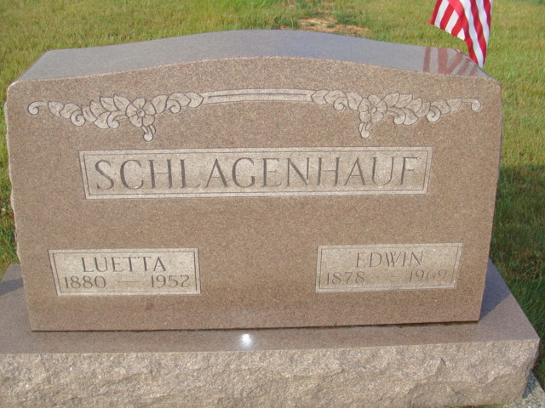
Photo by Alicia Kneuss

RITES SATURDAY FOR WIFE OF ED SCHLAGENHAUF
Prominent Woman of West of Berne Dies After Long Illness
Mrs. Luetta Liddy Schlagenhauf, 71, wife of Ed Schlagenhauf, living seven and one-half miles west of Berne, along State Road (missing). was a member of the Old Salem EUB Church, a member of the Women's Missionary Society of the church and a teacher in the Sunday School for many years.
The deceased was a native of Linn Grove, being born there Dec. 28, 1880, the daughter of Joel and Atlanta Hill Liddy. She was married to Ed Schlagenhauf Feb. 9, 1901, at Linn Grove. The couple observed their golden wedding anniversary last year.
Surviving is Mr. Schlagenhauf, a prominent farmer; one son, Harold Schlagenhauf of Geneva, ?? daughters, (missing) Miss Lela Schlagenhauf, E. (Ruth) Manley, Battle Creek, Michigan, and Mrs. Herman G. (Eileen) Reiff, Bluffton; eleven grandchildren and five great-grandchildren; four sisters, Mrs. Albert Huser, Mrs. Leonard Baumgartner and Mrs. Archie Paar, all of Berne and Mrs. Henry Sprunger, Saginaw, Michigan, and the step-mother, Mrs. Mary E. Liddy, 164 West Water Street in Berne. Three sisters, who died in infancy and two brothers preceded in death.
The body is at the Yager Funeral Home where friends may call. Services will be held at the funeral home at 2 p.m. Saturday, Rev. Raymond L. Cox, pastor of the Old Salem Church officiating. Burial will be in the MRE Cemetery.
Adams County, Indiana Historical Museum
1952Sep-Dec1953 Scrapbook, Image 35
Handwritten-Fri. Oct. 22, 1952

