Edwin Schlagenhauf
January 21, 1878 – April 5, 1969

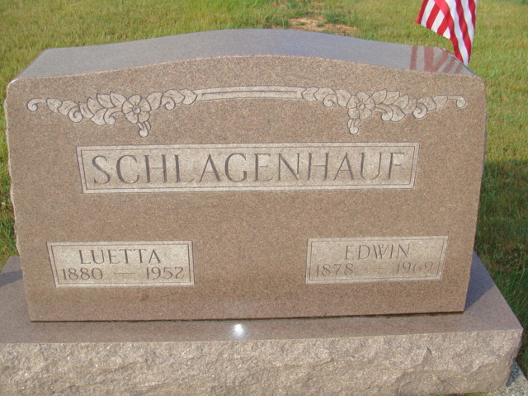
Photo by Alicia Kneuss

Edwin Schlagenhauf is taken by death

Edwin Schlagenhauf, 91, retired farmer of Bluffton Route 3, died at 2:48 p.m. Saturday at Swiss Village, following an illness of nine months.
A lifelong resident of Wells County, he was born in Harrison Township Jan. 21, 1878, a son of John and Luticia Gentis-Schlagenhauf, and was married to Luetta Liddy Feb. 9, 1900. His wife preceded him in death. Mr. Schlagenhauf was a member of the Old Salem United Methodist Church.
Surviving are one son, Harold Schlagenhauf of Geneva; six daughters, Mrs. Frank (Ruby) Sprunger of Berne, Mrs. Kenneth (Devona) Snyder of Churubusco, Miss Lila Schlagenhauf of Bluffton, Mrs. Marcella Myers of Berne, Mrs. Richaerd E. (Ruth) Manley of Battle Creek, Mich., and Mrs. Joe (Eileen) Compton of Bluffton; one sister, Mrs. Minnie Fuller of Downey, Calif.; 15 grandchildren, 21 great-grandchildren, and one great-great-grandchild. Three brothers and three sisters are deceased.
Services will be held at 10 a.m. Tuesday at the Yager Funeral Home in Berne, with Rev. Laverne Howard and Rev. A. J. Neuenschwander officiating. Burial will be in MRE Cemetery. Friends may call at the funeral home after 3 p.m. today.

Decatur Daily Democrat, Adams County, Indiana
Monday, April 7, 1969

