William Schindler
October 10, 1873 – March 23, 1949

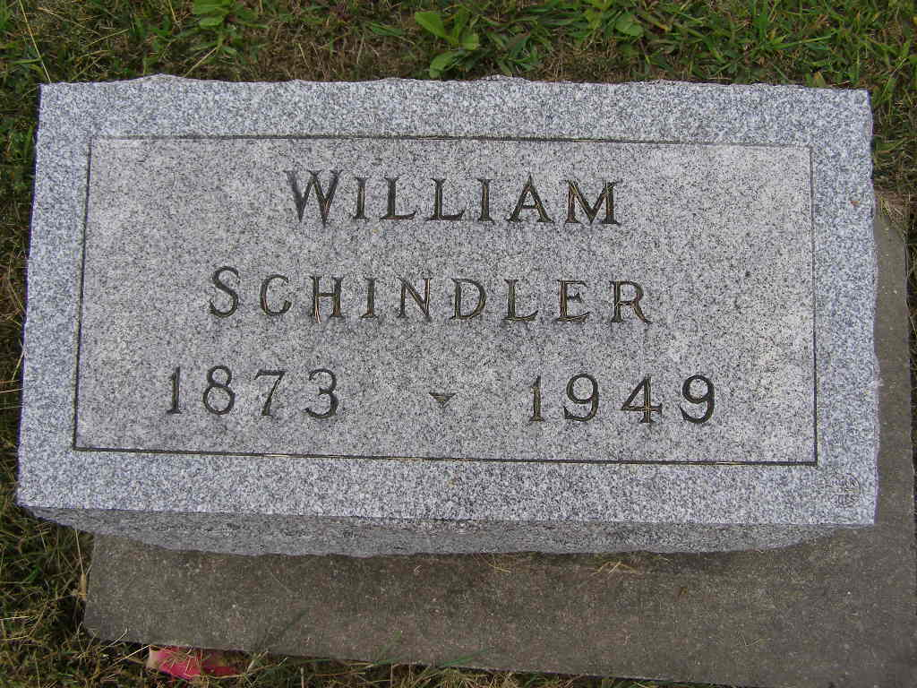
Photo by Shaunda Bedwell Opdycke
Indiana, U.S., Death Certificates, 1899-2017

Name William Schindler
Gender Male
Race White
Marital Status Never Married (Single)
Age 75
Birth Date 10 Oct 1873
Birth Place French Township
Death Date 23 Mar 1949
Death Place Berne, Adams, Indiana, USA
Death Registration Date 1949
Father John Schindler
Mother Lydia Augeburger
Informant Miss Sarah Schindler
Burial 3-26-1949 M. R. E. Cemetery

