Walter “Bud” Schindler
December 13, 1915 – March 29, 2001

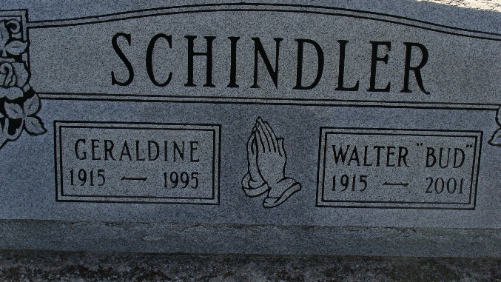
Photo by Alicia Kneuss

Retired Indiana State Police detective and former Bluffton insurance agent, Walter "Bud" Schindler, 85, of Delaware, Ohio, died at 11:52 a.m. Thursday at Grady Memorial Hospital in Delaware.
Mr. Schindler was a former resident of Berne and served from 1942 to 1966 as a state trooper and subsequently as a state police detective. After retirement from the law enforcement agency, he became engaged as an insurance representative with the Business Men's Assurance office in Bluffton. He was a member of the First Missionary Church at Berne.
He was born in Adams County Dec. 13, 1915 to Amos and Sarah Winteregg Schindler. His wife, Geraldine "Gerri" to whom he was married on Nov. 23, 1938, died in 1995.
Surviving are two daughters, Mrs. Don (Anita) Dyck of Delaware, Ohio, and Mrs. Steve (Nan) Habegger of Knoxville, Tenn.; a sister, Edith Crumpton of Ridgeway, S.C.; a brother, Clarence Schindler of Statesville, N.C.; four grandchildren; and three great-grandchildren. Two brothers and three sisters are deceased.
Services at 2 p.m. Sunday will be at Yager-Kirchhofer Funeral Home in Berne with Rev. Robert Dye officiating. Burial will be in MRE Cemetery. Calling hours at the funeral home will be Saturday from 7 to 8 p.m. and Sunday for one hour prior to services. Memorials to Miracle Hill Ministries in Greenville, S.C.

Bluffton News Banner, Wells County, Indiana
Unknown date

