Waldo Schindler
April 8, 1906 – December 18, 1990

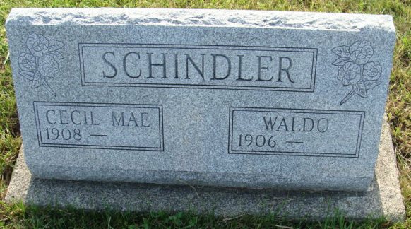
Photo by Alicia Kneuss

Rev. Waldo and Cecil Schindler, Bradenton, Fla., retired missionaries from the Congo, died in a semi-truck-car accident on Highway 64 in Florida yesterday afternoon. Rev. Schindler died instantly and his wife died two hours later in a Tampa hospital.
Surviving are three daughters, Mrs. Lois (Vernon) Lehman, Mrs. James (Mary) King, Mrs. Paul (Margaret) Hilton, all of Fort Wayne; a sister-in-law, Delma Schindler, Berne. A brother of Waldo Schindler, preceded in death.
Services are at 2 p.m. at Bradenton Missionary Village, Florida

Berne Tri-Weekly News, Adams County, Indiana
Wednesday, December 19, 1990
**

WALDO SCHINDLER
CECIL M. SCHINDLER
Waldo Schindler, 84, and Cecil Mae Schindler, 82, Bradenton, Florida, brother and sister-in-law of a Decatur woman, were killed Tuesday in a traffic accident in Bradenton.
They were retired missionaries from the Christian Missionary Alliance in Fort Wayne, having spent 34 years in Tabon, Africa. They moved from Fort Wayne to Bradenton in 1983.
Surviving are three daughters; 10 grandchildren; 11 great-grandchildren; Mr. Schindler's two sisters, including Florence E. Sheets, 404 Gage Ave., and Mrs. Schindler's sister.
Memorial services are pending at First Missionary Church, Fort Wayne. Burial will be in Bradenton.

Decatur Daily Democrat, Adams County, Indiana
Thursday, Dec. 20 1990
**
Waldo Schindler, 84 and Cecil Mae Schindler, 82, died Tuesday evening in Bradenton, Fla., in an auto accident. They were retired missionaries from Christian Missionary Alliance, Fort Wayne and served in Tabon, Africa for 34 years. In 1982 the couple moved from Fort Wayne to Bradenton, Fla.
Surviving are three daughters, Lois R. Lehman and Margaret A. Robinson both of Fort Wayne, and Mary E. King of Harlan; 10 grandchildren and 14 great grandchildren. Mr. Schindler also is survived by two sisters, Florence Sheets of Decatur and Margaret Bauserman of Kalamazoo, Mich. Mrs. Schindler is survived by a sister Mildred Miller of Washington, D.C. Memorials services are pending at First Missionary Church, 701 W. Rudisill Blvd. Burial in Bradenton, Fla. Arrangements by Bradenton Funeral Home, Bradenton.

Ft. Wayne Journal Gazette, Allen County, Indiana
Thursday, December 20, 1990, p. 6C
**

Florida, U.S., Death Index, 1877-1998

Name Waldo Schindler
Race White
Age at Death 84
Birth Date 8 Apr 1906
Death Date 18 Dec 1990
Death Place Manatee, Florida, United State

