Velma I. (Price) Schindler
January 2, 1913 – June 2, 2005

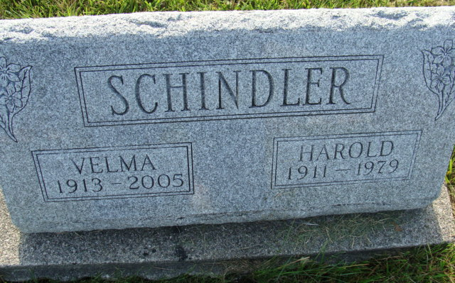
Photo by Alicia Kneuss

Indiana, U.S., Death Certificates, 1899-2017

Name Velma Schindler
[Velma Price]
Gender Female
Race White
Marital Status Widowed
Age 92
Birth Date 2 Jan 1913
Birth Place Fressenden, North Dakota
Death Date 2 Jun 2005
Death Place Berne, Adams, Indiana, USA
Death Registration Date 2005
Father William Price
Mother Martha Neuenschwander
Informant Kent Schindler, son
Burial 6/6/2005 M.R.E.

