Vaughn Benton Schindler
March 20, 1925 – November 16, 2020

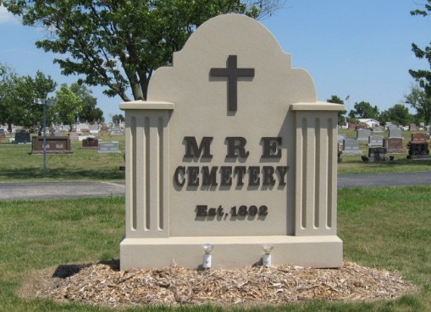
Photo by Tombstoner & Family

Vaughn Benton Schindler, age 95, of Berne passed away at Swiss Village on November 16, 2020. He was born in Berne on March 20, 1925, to John W. and Alieda (Sprunger) Schindler. He was married on Jan. 22, 1950, to Patricia Lou (Reusser) Schindler. He was an electrical contractor and the owner of Schindler Electric in Berne for 40 years before retiring in 1990.
He was a Captain in the U.S. Air Force and served in the Pacific during WWII. He also served two years in France during the Korean War. His wife and daughter lived with him in France during his years of service there.
He was a charter member of Berne Lions Club, a member of American Legion Post 468, former member of the Berne Volunteer Fire Department and a former member of the Berne Library Board. He was a member of Trinity United Methodist Church in Berne and served on various church committees throughout the years.
He is survived by two daughters: Deborah K. Dingledy of Indianapolis and Anne M. (Dave) Stauffer of Berne, one son: John W. (Nancy) Schindler of League City, Texas; seven grandchildren: Eric (Jessica) Dingledy, Mark Dingledy, Todd (Jennifer) Stauffer, Jenna Stauffer, Dr. Nick (Jandi) Schindler, Jeff Schindler, Alex Schindler; and three great-grandchildren: Lucas and Tyler Schindler and Rowan Dingledy.
He was preceded in death by his wife Pat, his parents and brothers Lt. Colonel Hallman W. Schindler and Captain Ted K. Schindler.
Due to the COVID-19 pandemic, there will be no visitation. There will be a private viewing for family only with interment at MRE Cemetery in Berne.
Preferred memorials are to Swiss Village Samaritan Endowment or Trinity United Methodist Church.
Zwick & Jahn Funeral Home, Adams County, Indiana
November 21, 2020

