Capt. Ted K. Schindler
March 23, 1894 – February 4, 1945


Photo by Tombstoner & Family

FEAR TED SCHINDLER IS KILLED IN ITALY
In all probability Capt. Ted Schinder, pilot of a B-24 Liberator plane, son of Mr. and Mrs. John Schindler of Berne, was killed in the crash on Feb. 28, in Italy. The commanding officer of the group to which Capt. Schindler was attached, has written to the parents, stating that their son's plane was hard hit by flak and was seen to go into a spin, crashing into a mountain side. The officer also said that no parachutes were seen to open from the plane. Capt. Ted Schindler and his brother, Capt. Haliman Schindler, were outstanding pilots connected with the air force in Italy and each had received their promotions a few days before the fatal flight of the one brother. Capt. Ted Schindler had a least 30 missions to his credit, prior to the date of his being reported missing in action over Italy.
Decatur Daily Democrat, Adams County, Indiana
Monday, March 26, 1945
Note: memorial in Jefferson Barracks National Cemetery, Lemay, St. Louis County, Missouri, USA; Plot: SECTION 82 SITE 77-79
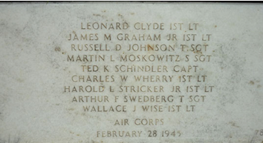
**
Capt. Ted R. Schindler
"Cemetery records of Adams County, Indiana"
Mary Penrose Wayne Chapter, D.A.R. Date: 1961.
Transcribed for Genealogy Trails by Barb Z.
In a circle are 9 white crosses each representing a soldier of World War II.

