Selena Schindler
March 23, 1894 – February 4, 1945

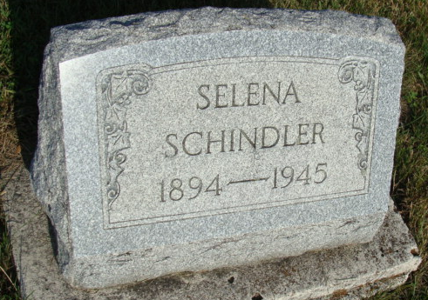
Photo by Alicia Kneuss

Indiana, U.S., Death Certificates, 1899-2017
Name Selena Schindler
Gender Female
Race White
Marital Status Single
Age 50y 10m 11d
Birth Date 23 Mar 1894
Birth Place Indiana Adams Colorado
Death Date 4 Feb 1945
Death Place Berne, Adams, Indiana, USA
Death Registration Date 1945
Father David Schindler
Mother Catherine Schlatter
Informant Edw. Schindler
Burial 2-6-1945 M.R.E.

