Samuel Schindler
July 29, 1882 – February 27, 1968

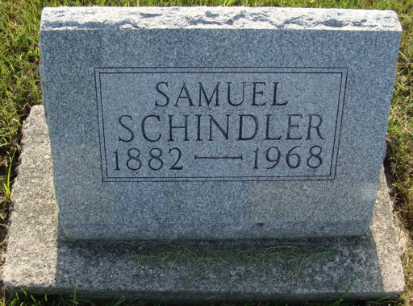
Photo by Alicia Kneuss

Samuel Schindler dies late Tuesday

Samuel Schindler, 85, a resident of the Berne Nursing Home for 13 years, died Tuesday at 7:00 pm of cardiac failure. He had been seriously ill the last few days. Mr. Schindler was born July 29, 1882 in French Township to David and Elizabeth Schlatter Schindler, both deceased. He lived most of his life in this county and worked as an upholsterer with Smith Brothers Furniture Co. for twenty years. Mr. Schindler lived in Hesperia, Mich., a few years and spent the rest of his life here.
Survivors are two sisters: Ellen, Fort Wayne, and Mrs. Henry (Cassie) Winteregg of Berne. Seven brothers and two sisters, Noah, Menno, Simon, Joe, Edwin, Elmer, John, Selena and Elizabeth are deceased.
Friends may call after 7:00 pm today at the Yager Funeral Home, where services will be held Thursday afternoon at 1:30. Rev. Gerald Gerig will officiate, with burial at MRE Cemetery.

Date of Burial: Thursday, February 29, 1968
Burial: Lot 526 – Original Platt

Berne (IN) Library Heritage Room
MRE Obit Book 1966-1972, image 133

