Rufus Schindler
May 26, 1877 – August 24, 1957

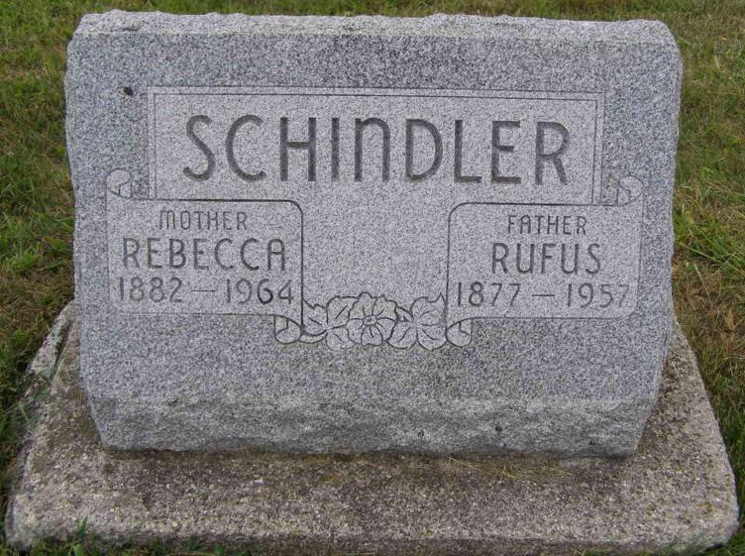
Photo by Shaunda Bedwell Opdycke

Rufus Schindler
in the Indiana, U.S., Death Certificates, 1899-2011
Name: Rufus Schindler
Gender: Male
Race: White
Age: 80
Marital status: Married
Birth Date: 26 May 1877
Birth Place: Indiana
Death Date: 24 Aug 1957
Death Place: Berne, Adams, Indiana, USA
Father: John Schindler
Mother: Lydia Augsburger
Informant: Alton Schindler; son; Berne, Indiana
Burial: August 27, 1957; MRE Cemetery; Berne, Indiana

