Reuben Schindler
February 1, 1873 – November 3, 1953

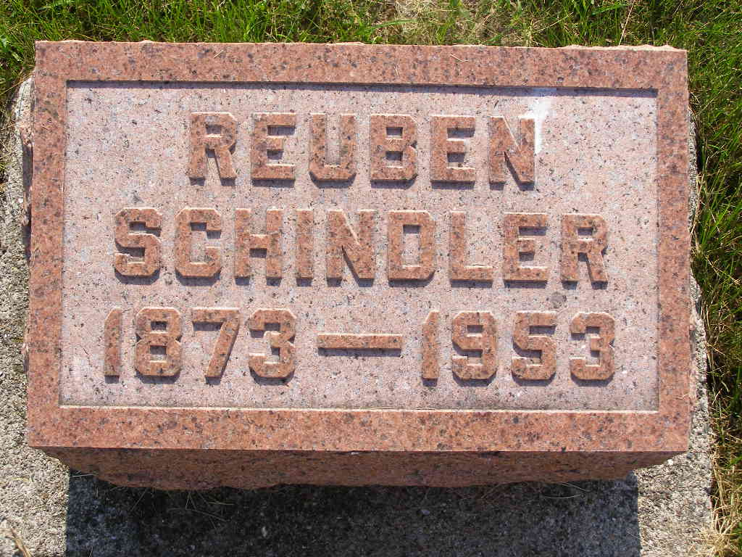
Photo by Shaunda Bedwell Opdycke

Reuben Schindler
in the Indiana, U.S., Death Certificates, 1899-2017
Name Reuben Schindler
Gender Male
Race White
Marital Status Widowed
Age 80
Birth Date 1 Feb 1873
Birth Place Adams County, Indiana
Death Date 3 Nov 1953
Death Place Fort Wayne, Allen, Indiana, USA
Death Registration Date 1953
Father Christian Schindler
Mother Barbara Liechty
Informant Ervin Schindler
Burial 11/6/1953 M.R.E. cemetery

