Randall W. Schindler
November 20, 1961 – May 28, 2007

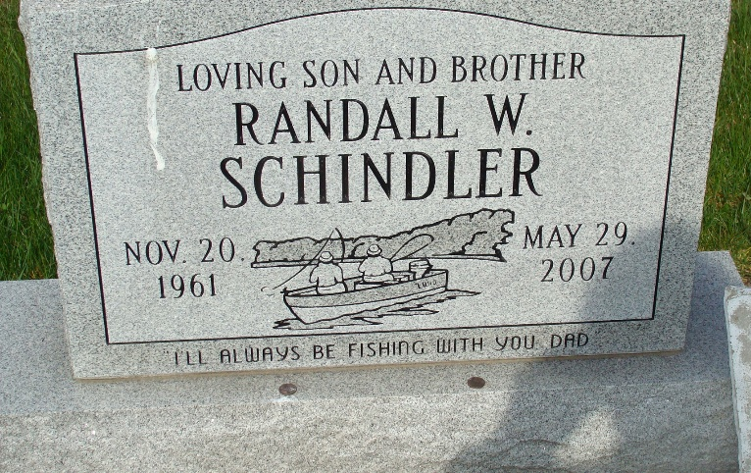
Photo by Alicia Kneuss
Randall W. "Randy" Schindler, 45 years old of Berne, Indiana, passed away on Monday, May 28, 2007 at his residence. He was born on Monday, November 20, 1961 in Wells County, Indiana the son of the late Lester Schindler and Beverly (White) Shindler.
Randy attended the Bridge Church in Decatur, Indiana. He was a graduate of South Adams High School and was employed at Revenge Designs LLC in Decatur. He was a member of the Berne American Legion and loved to hunt and fish.
Surviving are his mother & step-father, Beverly & James Richards of Geneva, Indiana, sister, Susan (Chris) Heidenreich of Fort Wayne, Indiana, and nephews, Zachary & Joshua Wolf of Fort Wayne, Indiana.
Funeral services will be held at 10:30 a.m. Saturday, June 2, 2007 in the Yager Kirchhofer Funeral Home with Rev. James Bontrager officiating. Interment will follow in the M.R.E. Cemetery. Friends will be received from 2:00 p.m. to 8:00 p.m., Friday, June 1 and one hour prior to the service on Saturday.
Preferred memorials are to an Education Fund for his nephews.

Yager-Kirchhofer Funeral Home, Adams County, Indiana

