Ralph Schindler
October 15, 1905 – August 7, 1980

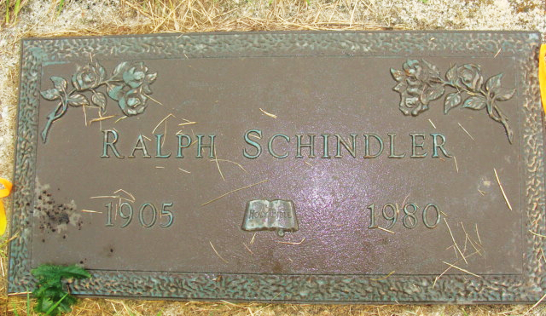
Photo by Alicia Kneuss

Ohio, U.S., Death Records, 1908-1932, 1938-2022

Name Ralph L Schindler
Gender Male
Race White
Marital Status Married
Death Age 74
Birth Date Abt 1906
Birth Place Indiana, USA
Death Date 7 Aug 1980
Death Place Cleveland, Cuyahoga, Ohio, USA
Certificate Number 055530
Inquest Hospital Cleveland Clinic Hospital
Inquest Questions Certifier: Physician; Autopsy Performed?: No Autopsy Performed
**

Indiana, U.S., Marriages, 1810-2001

Name Ralph Schindler
Gender Male
Race White
Age 36
Event Type Marriage Registration (Marriage)
Birth Date 15 Oct 1905
Birth Place Berne, Indiana
Marriage Date 3 Jul 1941
Marriage Place Indiana, United States
Residence Place North Manchester, Indiana
Father Amos Schindler
Mother Sarah Winteregg
Spouse Ida Lois Weimer
Page 327

