Patricia Lou (Reusser) Schindler
March 18, 1928 – June 16, 2019

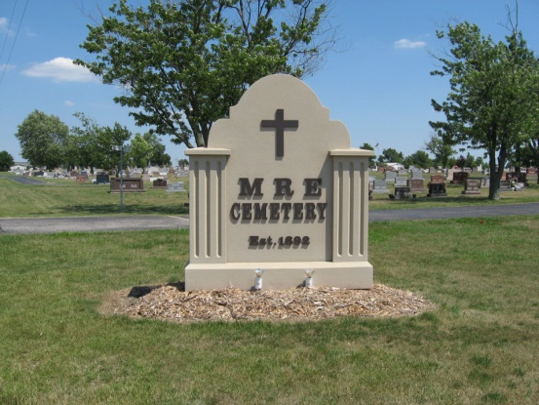
Photo by Tombstoner & Family
Patricia Lou Schindler, 91, of erne passed away at Swiss Village on June 16, 2019. She was born in Berne on March 18, 1928, to Walter and Lillian (Ehrsam) Reusser of Berne. She was married on January 22, 1950, to Vaughn Benton Schindler.
Upon graduation from Berne High School, she worked as a telephone operator for the Citizens Telephone Company in Berne, and then moved to Evanston, Illinois, for one year and worked at The Cradle Adoption Agency, where she enrolled in a special nursing program for the care of infants. She worked the remaining years of her career at Schindler Electric, the family-owned business in Berne.
She was a member of Trinity United Methodist Church in Berne, Indiana, and taught children’ Sunday school for many years.
She is survived by her husband, Vaughn Schindler of Berne, two daughters, Deborah K. Dingledy of Indianapolis and Anne M. (Dave) Stauffer of Berne; a son, John W. (Nancy) Schindler of League City, Texas; seven grandchildren, Eric (Jessica) Dingledy, Mark Dingledy, Todd Stauffer, Jenna Stauffer, Dr. Nick (Jandi) Schindler, Jeff Schindler, Alex Schindler; and three great-grandchildren, Lucas & Tyler Schindler & Rowan Dingledy.
She was preceded in death by her parents; a brother, Wayne Reusser; & a sister, Berneta Reusser.
A funeral service will be held at 11:00 a.m. Saturday, June 22, 2019 at the Swiss Village Auditorium with Pastor Mark Walus & Chaplain Mike Wertenberger officiating. Burial will follow at MRE Cemetery.
Family & friends will be received from 9:30 to 11:00 a.m. Saturday at the Swiss Village Auditorium.
Preferred memorials are to Swiss Village Samaritan Endowment or Trinity United Methodist Church.
Arrangements by Zwick & Jahn Funeral Home, Yager-Kirchhofer Chapel in Berne, Indiana.

Zwick & Jahn Funeral Home, Adams County, Indiana
Tuesday, June 18, 2019

