Ornell M. Schindler
February 16, 1908 – September 15, 2002

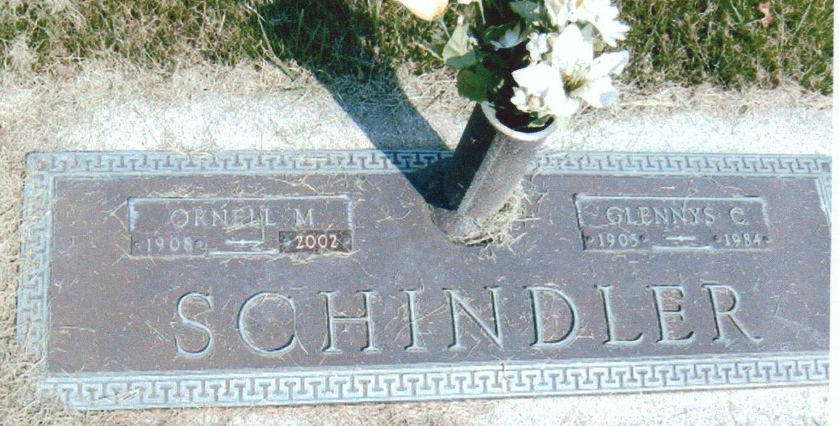
Photo by JC

Ornell M. Schindler, 94, of Berne, a World War II Army Air Forces veteran who received the Purple Heart award, died Saturday, Sept. 14, 2002, at Swiss Village Retirement Community. The Adams County native worked at United Milk Products for 30 years and also Arnold Lumber Co. in Decatur for 15 years, before retiring in 1973. He was a member of Cross United Church of Christ and Berne Lions Club.
Surviving are his brother, Marion Schindler of Celina, Ohio; stepsons Tom and Robert Wagley; and several nieces and nephews. He was preceded in death by his first wife, Glennys; his second wife, Syble; two sisters and a brother.
Services are noon Tuesday at Yager-Kirchhofer Funeral Home, Berne, with calling two hours before services. Graveside services by Adams Post 43 will be conducted at MRE Cemetery.
Memorials are to the church or donor's choice. Information provided by Yager-Kirchhofer Funeral Home, Berne, 1-260-589-3101.

News-Sentinel, The (Allen County, Indiana)
Monday, September 16, 2002

