Olive May Schindler
September 16, 1909 – December 27, 1985

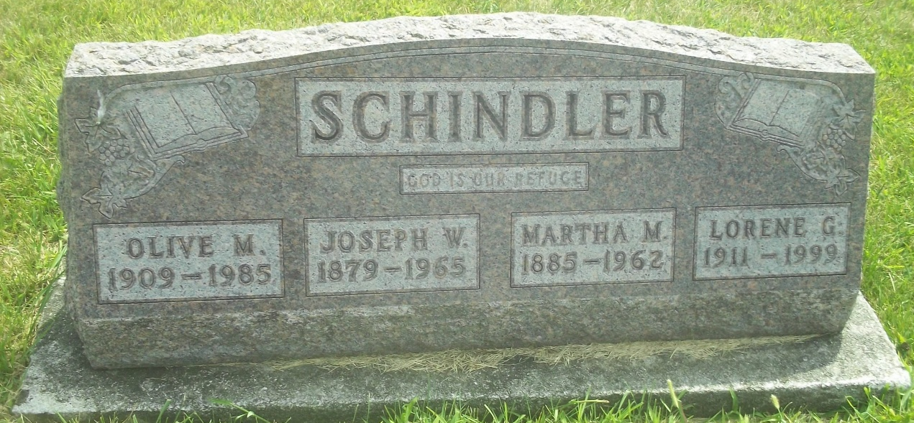
Photo by DSON1492

Indiana, U.S., Death Certificates, 1899-2017
Name Olive M Schindler
Gender Female
Race White
Marital Status Never Married (Single)
Age 76
Birth Date 16 Sep 1908
Birth Place Indiana
Death Date 27 Dec 1985
Death Place Berne, Adams, Indiana, USA
Death Registration Date 1985
Father Joseph W Schindler
Mother Martha Moser
Informant Lorene G. Schindler, sister
Burial M.R.E. 12-29-1985

