Noah Schindler
November 3, 1872 – January 31, 1954

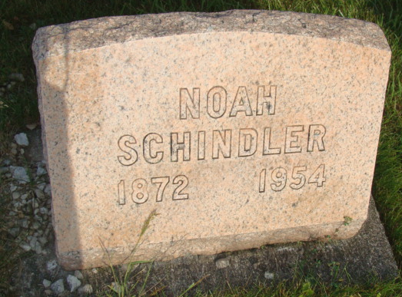
Photo by Alicia Kneuss
Indiana, U.S., Marriage Index, 1800-1941

Name Noah Schindler
Gender Male
Marriage Age 22
Birth Date abt 1872
Marriage Date 16 Sep 1894
Marriage Place Adams, Indiana, USA
Spouse Name Robecca Hirschy
Father Name David
Mother Name C Schlatter
**

Noah Schindler from tree Yoder-Rupp Families

Birth 3 Nov 1872 Indiana, USA
Marriage 16 Sep 1894 Indiana, USA
Residence 1930 Berne, Adams, Indiana, USA
Death 31 Jan 1954 Macomb, Macomb, Michigan, USA
Father David Schindler (1849-1933)
Mother Catherine Schlatter (1852-1933)
Spouse Rebecca Hirschey (1873-1957)
189864 People 12 Records 12 Sources

