Meno Schindler
January 25, 1884 – September 22, 1944

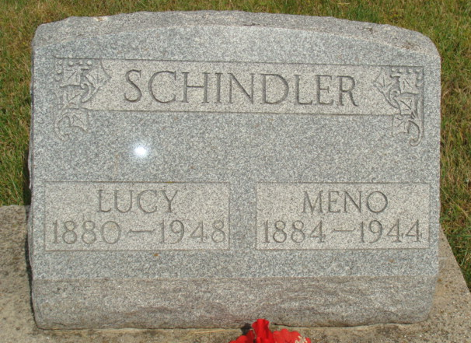
Photo by Alicia Kneuss
Indiana, U.S., Death Certificates, 1899-2017

Name Menno Schindler
Gender Male
Race White
Marital Status Married
Age 60y 2m 27d
Birth Date 25 Jun 1884
Birth Place French Township, Adams County
Death Date 22 Sep 1944
Death Place Berne, Adams, Indiana, USA
Death Registration Date 1944
Father David Schindler
Mother Catherin Schlatter
Spouse Lucy Moser Schindler, informant
Burial 9/25/1944 M. R. E.

