Max L. Schindler
October 10, 1927 – January 12, 1987

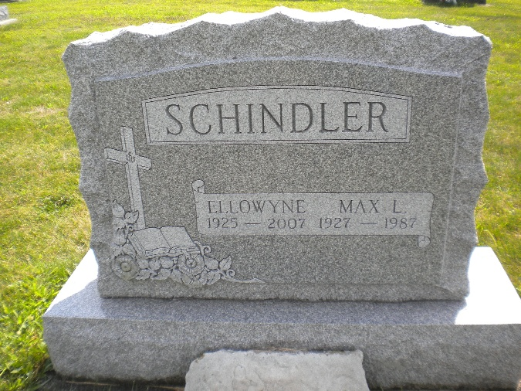
Photo by DSON1492

Indiana, U.S., Death Certificates, 1899-2017

Name Max L Schindler
Gender Male
Race White
Age 59
Marital Status Married
Birth Date 7 Oct 1927
Birth Place Indiana
Death Date 12 Jan 1987
Death Place Fort Wayne, Allen, Indiana, USA
Death Registration Date 1987
Father Alton Schindler
Mother Lillie Moser
Spouse Ellowyne Schindler, informant
Burial M.R.E. Jan 15, 1987

