Martha (Moser) Schindler
June 1, 1885 – May 16, 1962

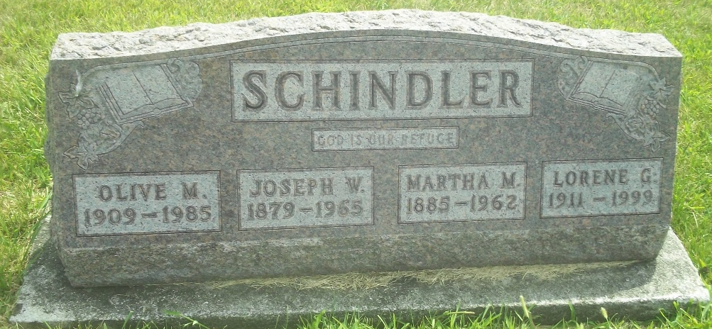
Photo by DSON1492

Wife Of Joseph Schindler Dies On Wednesday
Funeral Saturday For Local Woman, 76
Mrs. Martha Schindler, 76, wife of Joseph Schindler of 566 Center Street, died at 3:45 p.m. Wednesday at the Adams County Memorial Hospital after a long illness. Death was attributed to a heart condition. She had ailed for several years and had been bedfast the last six months.
A lifetime resident of this community, Mrs. Schindler was born June 1, 1885, in French Township, the daughter of John S. and Christine Steiner Moser. She was married to Joseph Schindler March 30, 1907, in Berne.
Surviving are the husband; two daughters, Olive and Lorene Schindler, both at home and a sister, Mrs. Harvey (Adele) Egly, Berne. Mrs. Alton (Lillie) Schindler of west of Berne was raised in the Schindler home. A daughter, Grace Lucile, died at the age of three years and five sisters, three brothers and a foster sister preceded in death.
Mrs. Schindler was a member of the West missionary Church where services will be held at 2 p.m. Saturday, Rev. Armin C. Steiner officiating. Burial will be in the M.R.E. Cemetery. Friends may call at the Yager Funeral Home.
Adams County, Indiana Historical Museum
1951Jan-Aug1962 Scrapbook, image 65
Handwritten-Fri. May 18, 1962

