Martha (Brown) Schindler
May 14, 1905 – September 16, 1966

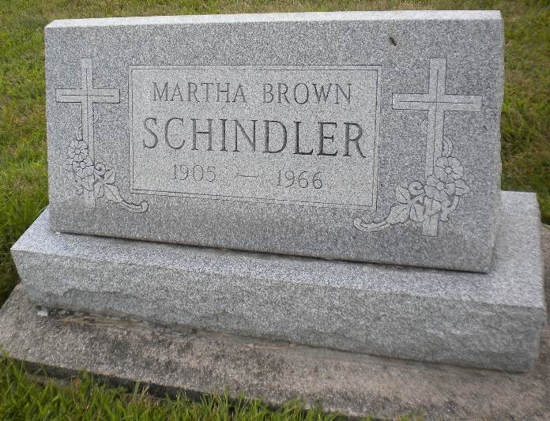
Photo by DSON1492
Funeral Here for Mrs. Martha Schindler

Funeral services were held Sunday afternoon at the First Missionary Church for Mrs. Martha Brown Schindler, 61, of Behring Street, who died at 6:55 pm Friday at the Adams County Memorial Hospital. Rev. Gerald Gerig officiated at the rites and burial was in the MRE Cemetery. Mrs. Schindler was a member of the First Missionary Church. Death was attributed to a cerebral hemorrhage and followed an illness of two days. She had suffered previous strokes.
She was a lifelong resident of Berne and was a seamstress for many years at Smith Brothers Furniture Company, retiring about nine years ago. Mrs. Schindler was born May 14, 1905 and was the daughter of Morris D. and Minnie Brown. Surviving are the mother and a sister, Mrs. Aldine Kessler. The Yager Funeral Home had charge of the services.

Date of Death: 16 September 1966; Date of Burial: 17 September 1966 Burial on: Lot 568 Orig. Platt

Berne (IN) Heritage Room
MRE Obits 1966-1972, image 032

