Margaret Jane (Steiner) Schindler
April 20, 1917 – October 12, 1998

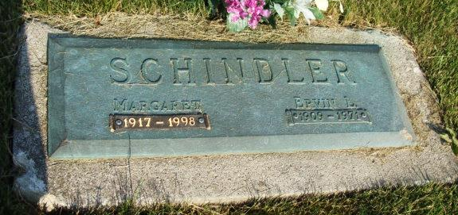
Photo by Alicia Kneuss

Indiana, U.S., Death Certificates, 1899-2017
Name Marjaret J. Schindler
[Marjaret J. Steiner]
Gender Female
Race White
Marital Status Widowed
Age 81
Birth Date 20 Apr 1917
Birth Place Adams County
Death Date 13 Oct 1998
Death Place Bluffton, Wells, Indiana, USA
Death Registration Date 1998
Father Hugo Steiner
Mother Agnes Parr
Informant Brian Schindler, son
Burial M.R.E. 10/15/1998

