Mahala (Biberstein) Schindler
January 21, 1891 – December 27, 1964

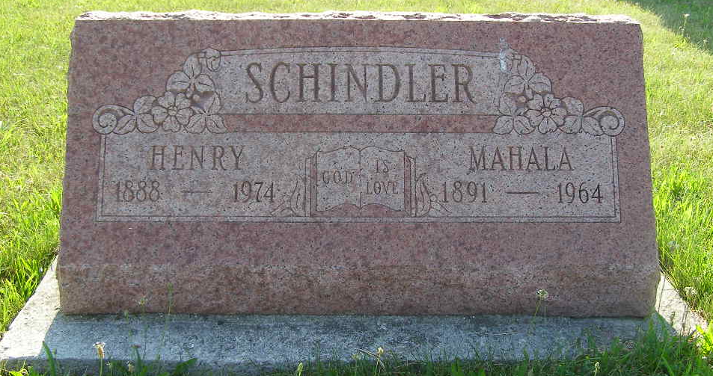
Photo by Shaunda Bedwell Opdycke

Indiana, Death Certificates, 1899-2011
Name: Mahala Schindler
[Mahala Bieberstein]
Gender: Female
Race: White
Age: 73
Marital status: Married
Birth Date: 21 Jan 1891
Birth Place: Indiana
Death Date: 27 Dec 1964
Death Place: Decatur, Adams, Indiana, USA
Father: Peter Bieberstein
Mother: Sarah Stenier
Spouse: Henry Schindler, informant
Burial: 12/30/1964 M.R.E.

