Lydia (Augsburger) Schindler
October 13, 1846 – June 12, 1928

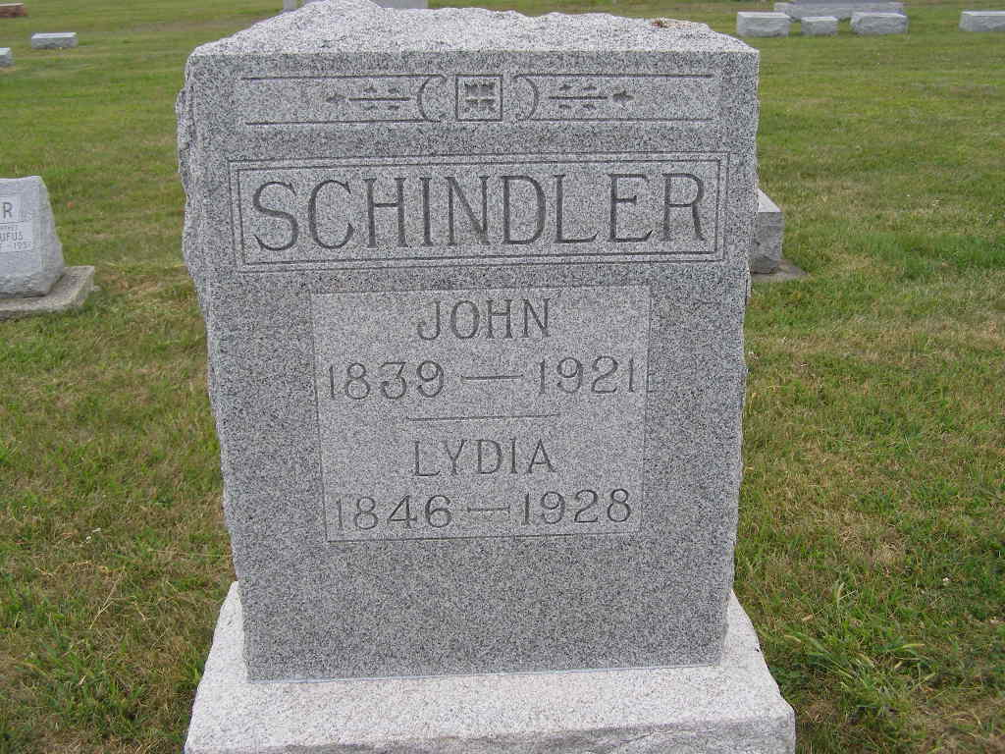
Photo by Shaunda Bedwell Opdycke

AGED HARTFORD TP. WOMAN IS DEAD
Short Illness Fatal to Mrs. John Schindler, 81, Tuesday Noon
Funeral Thurs.
Mrs. John Schindler, aged 81 years, nee Lydia Augsburger, died at 12:20 o'clock yesterday afternoon at her home in Hartford township a short distance north of the Jimtown bridge. Death came after a very brief illness with the flu of the bowels, followed by a stroke of paralysis. The aged grandmother was stricken ill on Monday evening with intestinal ailment and suffered severely during the night. Although advanced in years, her health had been fairly good which fact causes the report of her death to come quite unexpected to her relatives and friends.
Mrs. Schindler was a daughter of John and Mary Wenger Augs-burger. She was born in French township, directly two miles north of the home where she died. The date of her birth was October 13, 1846, which advances her age to 81 years, 7 months and 29 days. On March 9, 1869 she was united in marriage with Mr. Schindler, with whom she shared companionship until November 18, 1921 when her husband died. In 1877 they moved to the farm near the Wabash river, which they purchased during the year previous, and there they reared their family and spent the remainder of their lives.
Surviving are nine children. They are Mrs. William Egle of Berne, Levi and William at home, Rufus, Mrs. John Zimmerman of Hartford township, Barbara and Sarah at home, Mrs. Simon Zimmerman of Hartford township and Henry of Berne. Two brothers and three sisters also survive, who are David Augsburger and Mrs. Nick Stucky of Berne, Levi, Mary and Sarah Augsburger east of Berne.
Two children, Emma, in infancy and Susan, 19, and three brothers, John, Jacob and Chris, preceded her in death.
Funeral services will be held on Thursday afternoon at 1:30 o'clock from the home and at 2 o'clock from the West Missionary church of which she was a member. Burial will be at MRE cemetery. Rev. A. M. Clauser will officiate.

Adams County Witness (IN)
Wednesday, June 13, 1928
**

Indiana, U.S., Death Certificates, 1899-2017

Name Mrs Lydia Schindler
[Mrs Lydia Augsburger]
Gender Female
Race White
Marital Status Widowed
Age 81y 7m 29d
Birth Date 13 Oct 1846
Birth Place Indiana
Death Date 12 Jun 1928
Death Place Hartford, Adams, Indiana, USA
Death Registration Date 1928
Father John Augsburger b. Switzerland
Mother Mary Wenger b. Switzerland
Spouse John Schindler
Informant Sarah Schindler
Burial M.R.E. 6/14/1928
**

Indiana, U.S., Marriages, 1810-2001

Name Lydia Auxberger
Gender Female
Event Type Marriage Registration (Marriage)
Marriage Date 4 Mar 1869
Marriage Place Indiana, United States
Spouse John Schindler
Page 234
FHL Film Number 002321470

