Lucy (Moser) Schindler
January 23, 1880 – June 29, 1948

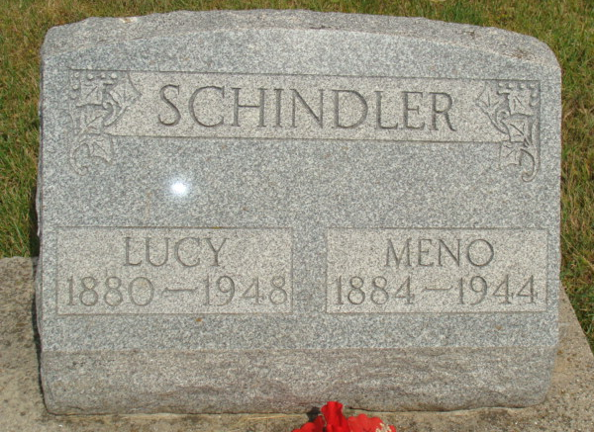
Photo by Alicia Kneuss
Berne, July 6 - Mrs. Lucy Moser Schindler, 58, widow of Menno Schindler, died at 9:20 am today in the Hossman Hospital here.
A native and lifelong resident of this community, she is survived by two sons, Marcus of Geneva and David, near Geneva; four grandchildren, five sisters, Mrs. Ernest Balsiger, Mrs. Joseph Schindler and Mrs. Harve Egly, all of Berne; Mrs. Jacob Yoder, near Berne, and Mrs. Oscar Maryatt, Hollywood, Calif., and a foster sister, Mrs. George Dyson, near Bluffton.
Funeral services will be conducted at 2 pm Thursday in the West Missionary Church of which she was a member, with the Rev. Oscar A. Eicher officiating. Burial will be in the MRE Cemetery. Friends may call at the Yager Funeral Home after 10 am Wednesday.

Journal-Gazette, Allen County, Indiana
July 7, 1948, Page 11

