Lorene Georgia Schindler
August 29, 1911 – January 4, 1999

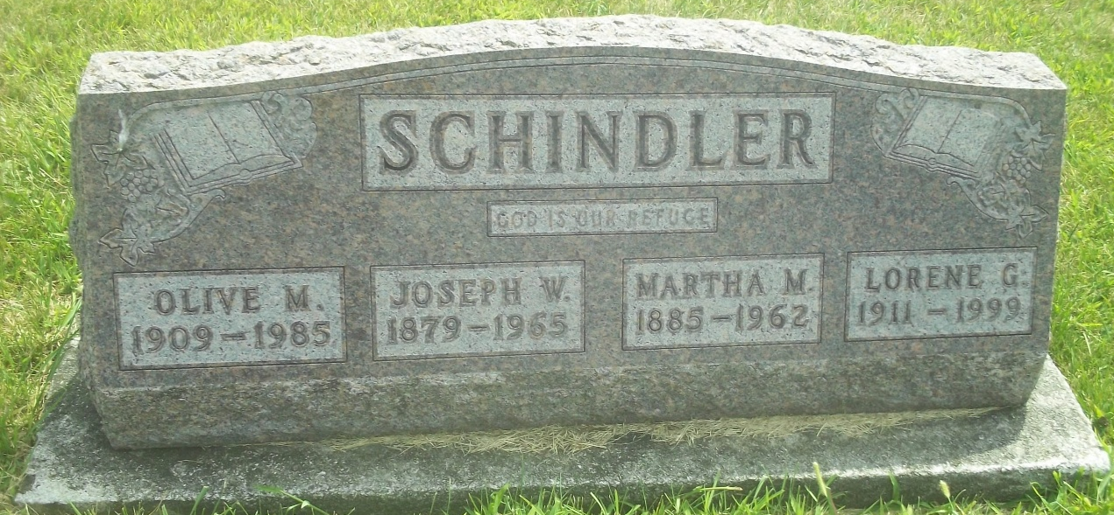
Photo by DSON1492

LORENE G. SCHINDLER, 87, died Monday in Huntington. She was a forewoman in the sewing department at Berco Co. for 50 years, retiring in 1990. Surviving are several cousins.
Services at 2:30 p.m. Thursday at West Missionary Church, rural Berne. Calling from 3:30 to 8 p.m. Wednesday and 9 a.m. to noon Thursday at Yager-Kirchhofer Funeral Home, Berne, and one hour before services at the church.
Memorials to the West Missionary Church Building Fund.

Journal Gazette, The (Allen County, Indiana)
Tuesday, January 5, 1999

