Lillie E. (Moser) Schindler
May 3, 1908 – October 25, 1979

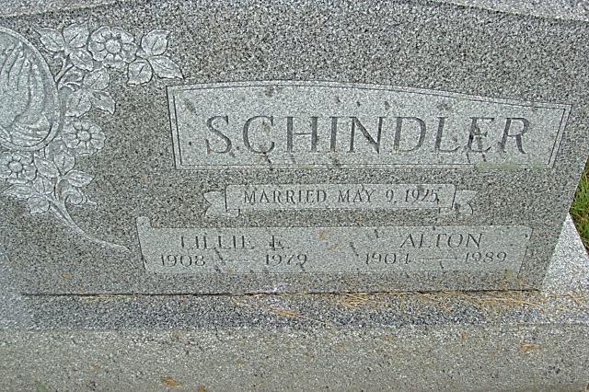
Photo by Alicia Kneuss
Indiana, U.S., Death Certificates, 1899-2017
Name Lillie E Schindler
[Lillie E Moser]
Gender Female
Race White
Age 71
Marital Status Married
Birth Date 3 May 1908
Birth Place Indiana
Death Date 25 Oct 1979
Death Place Bluffton, Wells, Indiana, USA
Death Registration Date 1979
Father Paul Moser
Mother Carrie Burry
Spouse Alton Schindler, informant
Burial M.R.E. Oct 27, 1979

