Levi L. Schindler
June 27, 1872 – January 12, 1949

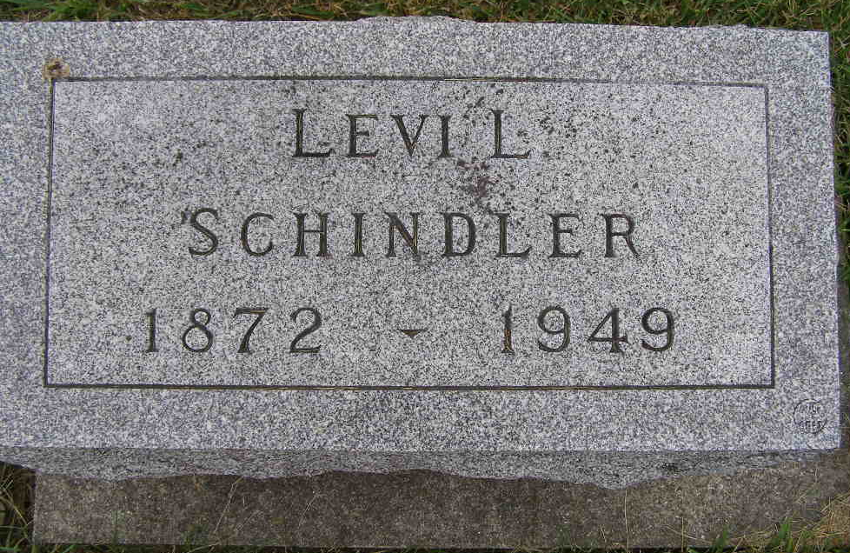
Photo by Shaunda Bedwell Opdycke
FUNERAL THIS AFTERNOON FOR LEVI SCHINDLER,
Funeral services were held at 2 o'clock this afternoon at the West Missionary Church for Levi Schindler (missing) A. Eicher officiated at the funeral and burial was in the M.R. E. Cemetery.
Mr. Schindler died at his home three miles west and one and a half miles south of Berne. He lived with his brother and sister, William and Sarah Schindler. He was a retired farmer. He was never married.
Mr. Schindler died after a brief illness. He complained Wednesday of not feeling well but was up and around as usual and ate dinner with the others at noon. Afterward he complained of pains in his chest but was about the house in the afternoon. He died while sitting in a chair where he was found by his sister, Sarah. His brother, William, who was in the same room with Levi, did not notice he had died. Death was believed to be caused by a heart attack.
The deceased was born in French Township, June 27, 1872, the son of John and Lydia Augsburger Schindler.
(missing) Four sisters preceded in death.
Mr. Schindler was a member of the West Missionary Church.
Adams County, Indiana Historical Museum
Dec1948-1949 Feb Scrapbook, Image 28
Handwritten-Fri. Jan. 14, 1949
**
Indiana, U.S., Death Certificates, 1899-2011
Name: Levi L Schindler
Gender: Male
Race: White
Age: 76
Marital status: Never Married (Single)
Birth Date: 27 Jun 1892 (sic – 1872)
Birth Place: French Township
Death Date: 12 Jan 1949
Death Place: Rural, Adams, Indiana, USA
Father: John Schindler
Mother: Lydia Augsburger
Informant: William Schindler; Berne, Indiana
Burial: January 14, 1949; MRE Cemetery; Berne, Indiana

